Visit The Hill
State Historical Building - Des Moines, Iowa
February 26th, 2026
Brought to you by:

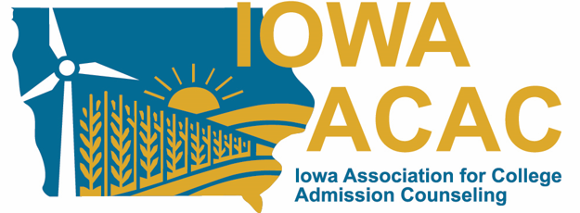

Agenda
9:00-9:30 – Check In (Atrium)
9:30-10:15 – Session 1 – Economic Impact Of Higher Education Within Local Communities
Ryan Roberts, Director of Government Relations for Community Colleges of Iowa
Emily Shields, Executive Director of Community Colleges for Iowa
Regent and Private Sector Representation - TBD
10:20-11:00 – Session 2 – FAFSA/Financial Aid Updates
Erick Danielson, VP of Programs for ICAN
11:05-11:45 – Session 3 – Keeping Track of State Capitol Happenings
Jim Obradovich, ISCA Lobbyist
Jefferson Fink, ISCA Lobbyist
11:45-12:30 – Lunch (Sandwiches, salad, chips, cookies, water, coffee, iced tea)
12:30 – Head to the Capitol to speak with legislators

